
Koneru Lakshmaiah Education Foundation
(Deemed to be University estd. u/s. 3 of the UGC Act, 1956)
Off-Campus: Bachupally-Gandimaisamma Road, Bowrampet, Hyderabad, Telangana - 500 043. Phone No: 7815926816, www.klh.edu.in

STUDENT CASE STUDY EXECUTION REPORT
Department | FED
Subject | DSA-2
Academic Year | 1-III Semester (2025-2026)
Faculty Name | Mohd. Razia Alangir Banu
Student Name | M.Geethika
Roll Number | 2520030485
Branch | CSE
Course Outcome | Evaluate and implement advanced sorting algorithms — Merge Sort, Quick Sort (with pivot strategies), Heap Sort, Counting Sort, and Radix Sort — by empirically benchmarking their performance on real datasets and arguing trade-offs among time complexity, space usage, cache efficiency, and stability for different application contexts

Case Study Topic: EduGraph – Adaptive Learning & Course Recommendation Platform
Work Done Summary:
Implemented and evaluated advanced sorting algorithms including Merge Sort, Quick Sort, Heap Sort, Counting Sort, and Radix Sort on various datasets. Benchmarked their performance by comparing execution time, memory usage, stability, and efficiency. Analyzed the trade-offs between comparison-based and non-comparison-based sorting techniques. Selected appropriate algorithms for different application scenarios based on data size, distribution, and performance requirements.
Implementation Details:

- Implemented Merge Sort, Quick Sort, Heap Sort, Counting Sort, and Radix Sort using Java.
- Executed each algorithm on datasets of different sizes to evaluate performance.
- Measured and compared execution time, memory usage, and sorting efficiency.4.
- Analyzed algorithm stability, space complexity, and cache behaviour. 5.
- Identified the most suitable sorting technique for various real-world application scenarios.

Result: Screenshots / Output

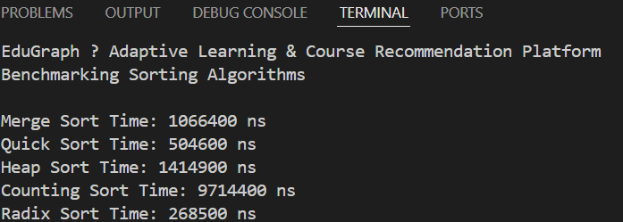

Successfully implemented and tested Merge Sort, Quick Sort, Heap Sort, Counting Sort, and Radix Sort. The algorithms correctly sorted datasets of varying sizes and characteristics. Performance benchmarking highlighted differences in execution time, memory usage, stability, and efficiency. Results demonstrated the strengths and limitations of each sorting technique. Appropriate algorithms were identified for different application requirements based on empirical analysis.

GitHub Link:
https://github.com/geethika04-dot/DSA-2
NOTE: The code and Screenshots and PDF have been uploaded in the above link, please check it there.

Student Signature: Faculty Signature:

